

Machine Learning – Lab 2
Neural networks

学 院 软件学院
专 业 软件工程
姓 名 朱本金
学 号 201430615165
邮 箱 poodarchu@gmail.com
指导教师 吴庆耀
提交日期 2016年11月11日

Data Analysis
Dataset: Wisconsin Diagnostic Breast Cancer (WDBC)
Number of instances: 569

Number of attributes: 32 (ID, diagnosis, 30 real-valued input features)

Attribute information
1) ID number
2) Diagnosis (M = malignant, B = benign)
3-32)
Ten real-valued features are computed for each cell nucleus:
a) radius (mean of distances from center to points on the perimeter)
b) texture (standard deviation of gray-scale values)
c) perimeter
d) area
e) smoothness (local variation in radius lengths)
f) compactness (perimeter^2 / area - 1.0)
g) concavity (severity of concave portions of the contour)
h) concave points (number of concave portions of the contour)
i) symmetry
j) fractal dimension ("coastline approximation" - 1)
Several of the papers listed above contain detailed descriptions of
how these features are computed.
The mean, standard error, and "worst" or largest (mean of the three
largest values) of these features were computed for each image,
resulting in 30 features. For instance, field 3 is Mean Radius, field
13 is Radius SE, field 23 is Worst Radius.
All feature values are recoded with four significant digits.

Missing attribute values: none

Class distribution: 357 benign, 212 malignant

Experiment Process
- Read the source code, referencing to the theory, make the working flow clear, make questions obvious.
- Implement the requested part in the soruce code. Then try on:
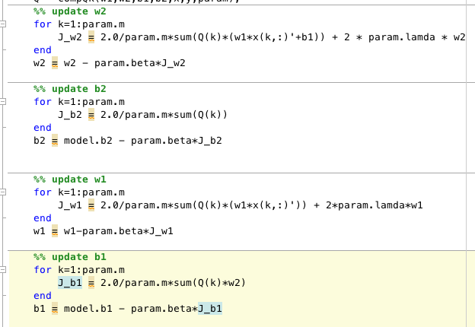
- Record the result, including the accurate rate, error-rate , etc.

Parameter:
This 3-layer neural network has many parameters:
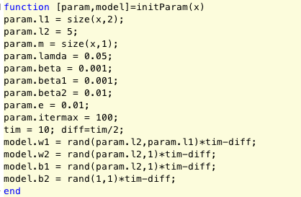
all of them can we change at our will, of course, it should make sense.
for example, I change the l2 layer’s unit num, the lamda, and learning rate beta, as well as the iteration_times, tim and diff.
the result will be shown below.

Experimental Baseline & Other Results
As the baseline, I put the first model result here:
The parameter looks like this, and the result is:
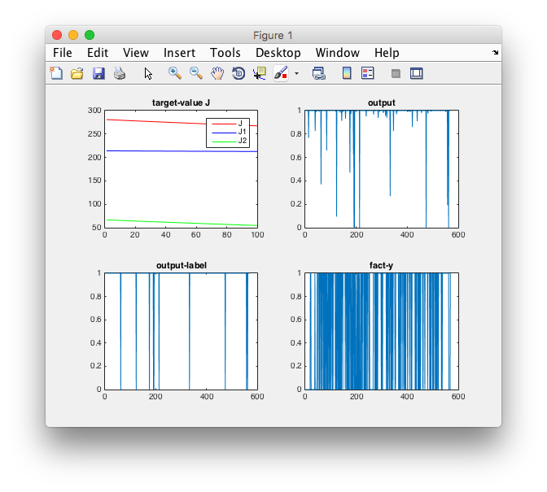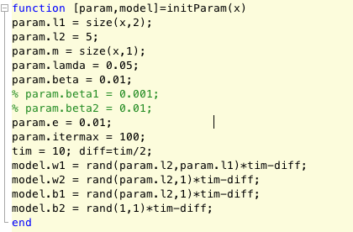
err=-0.121723, J=267.566234, b2=1.059591

acc = 0.6204

then I firstly change l2 to 10:
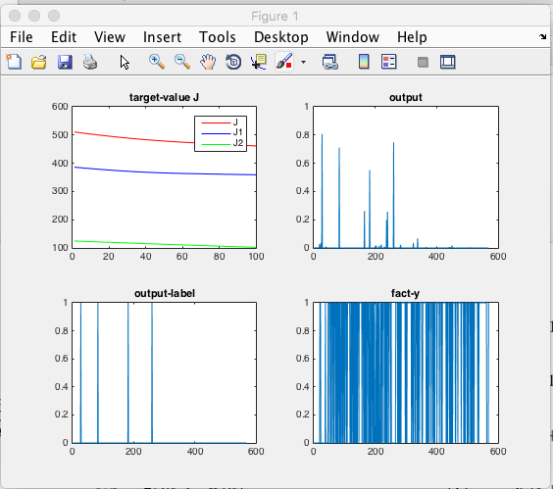
err=-0.304403, J=461.671481, b2=-4.266383
acc = 0.3656,
from this experiment, we can know that if the number of hidden layer’s unit is not properly set, the accurate will badly effected! 62% -> 36%

so, I change l2 back to 5, and start try to change lamda to 0.01:

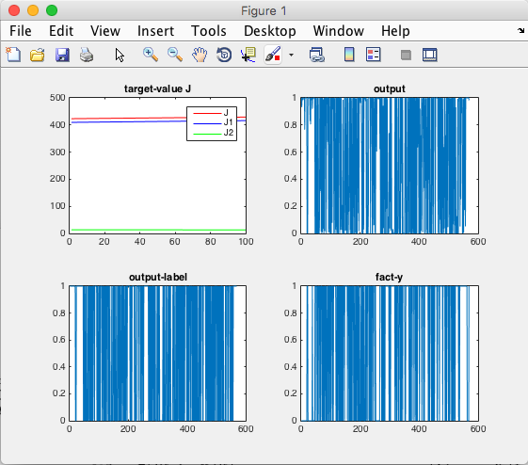
err=0.056981, J=429.158653, b2=-4.153508 acc = 0.2425
we can see that the outputs increase dramatically, but the accurate didn’t do this correspondingly. J1 nearly keeps, but J and J2 decrease by about 100.
This shows that the normalization part of the loss function will effect the smooth-or-not of the decision boundary.

Then , I change lamda back to 0.05, then tune the learning rate beta.
- Beta-> 0.02
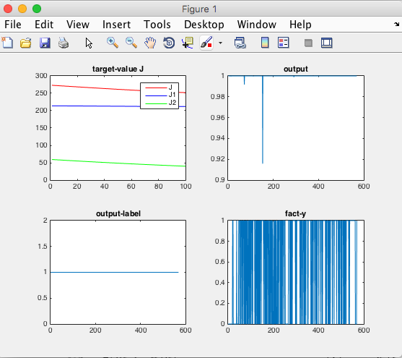
err=-0.161027, J=252.057781, b2=4.579758 acc = 0.6274
- 0.01 for layer 1, 0.001 for the hidden layer:
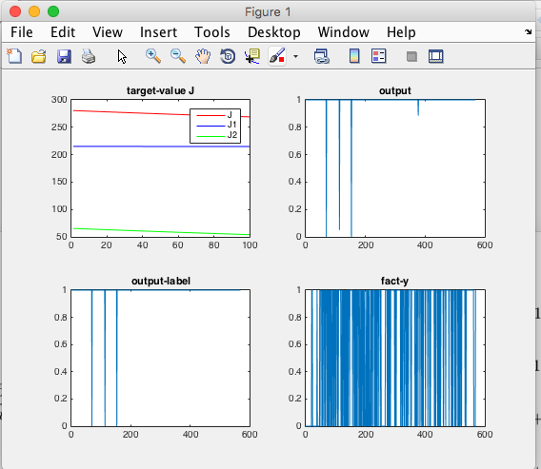
err=-0.106204, J=269.059657, b2=0.714131 acc = 0.6221
it nearly doesn’t import at all.

Finally, I change error_threshold to 0.001, and max_iter to 500:
err=-0.053186, J=188.056705, b2=-1.432943 acc =0.6784
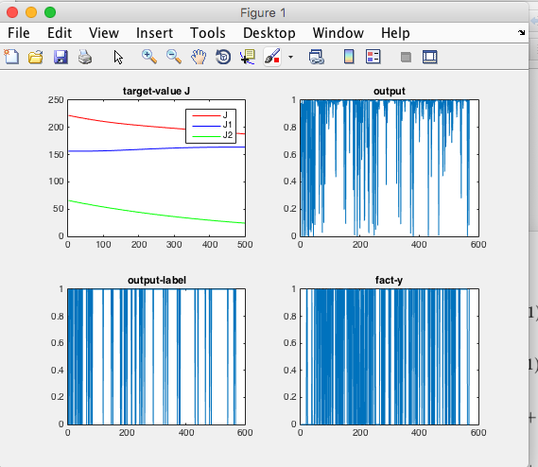
this time the model is more saticfying. With accurate improve from 62% -> 67%, and the output/ loss function are both qualified.

Discussion and Conclusion
From the neural network lab, I’m more familiar with it, and feel more about parameter fine tuning requires expert knowledge or pre-knownledge, the best way to achieve it , in my opinion , is to try it by youself.

Learning rate seems to be the less import factor
While number of units of the hidden layers is very import , we had better not always set it to a high value. The normalization parameter lamda controls the shape of the boundary, it shouldn’t be too large or too small.

If we can spend more time one the training, we’ll have a bigger chance of get a better model, of course, it doesn’t always the truth.

